Nama : Gede Satyamahinsa Prastita Uttama

NIM : 1203220054

Kelas : IF-02-03

**Latihan 1 Praktikum Algoritma Struktur Data – Array**

1. 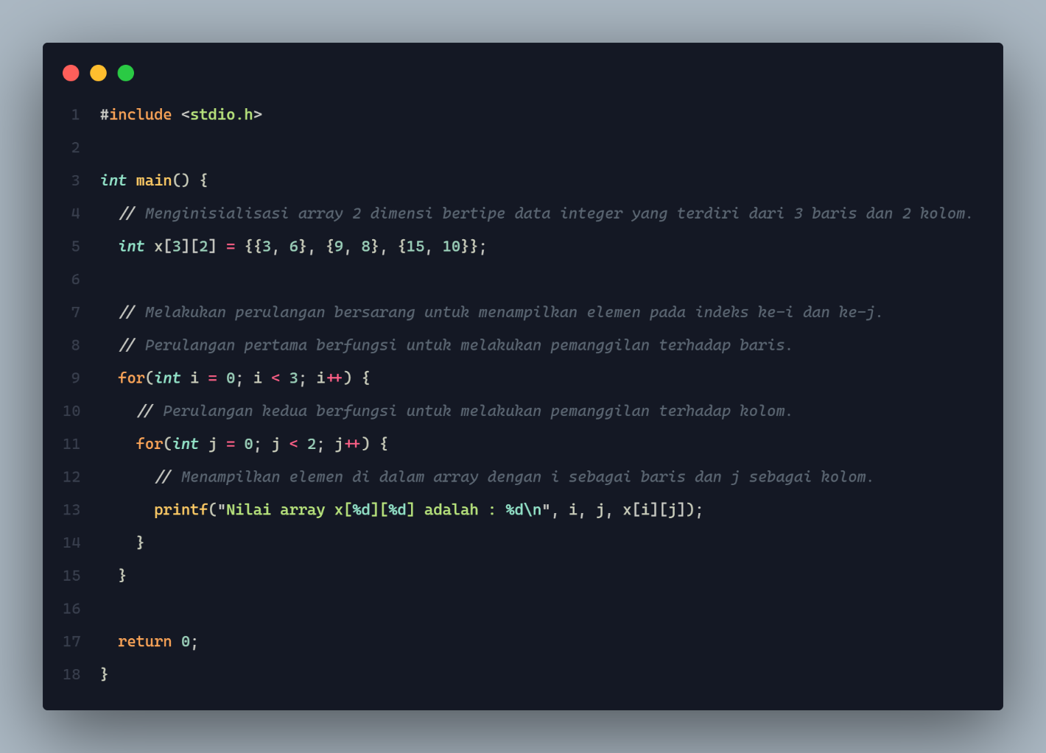Source Code:

Output:

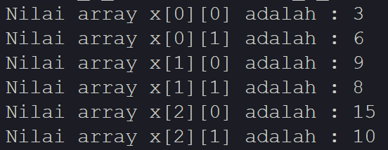

1. 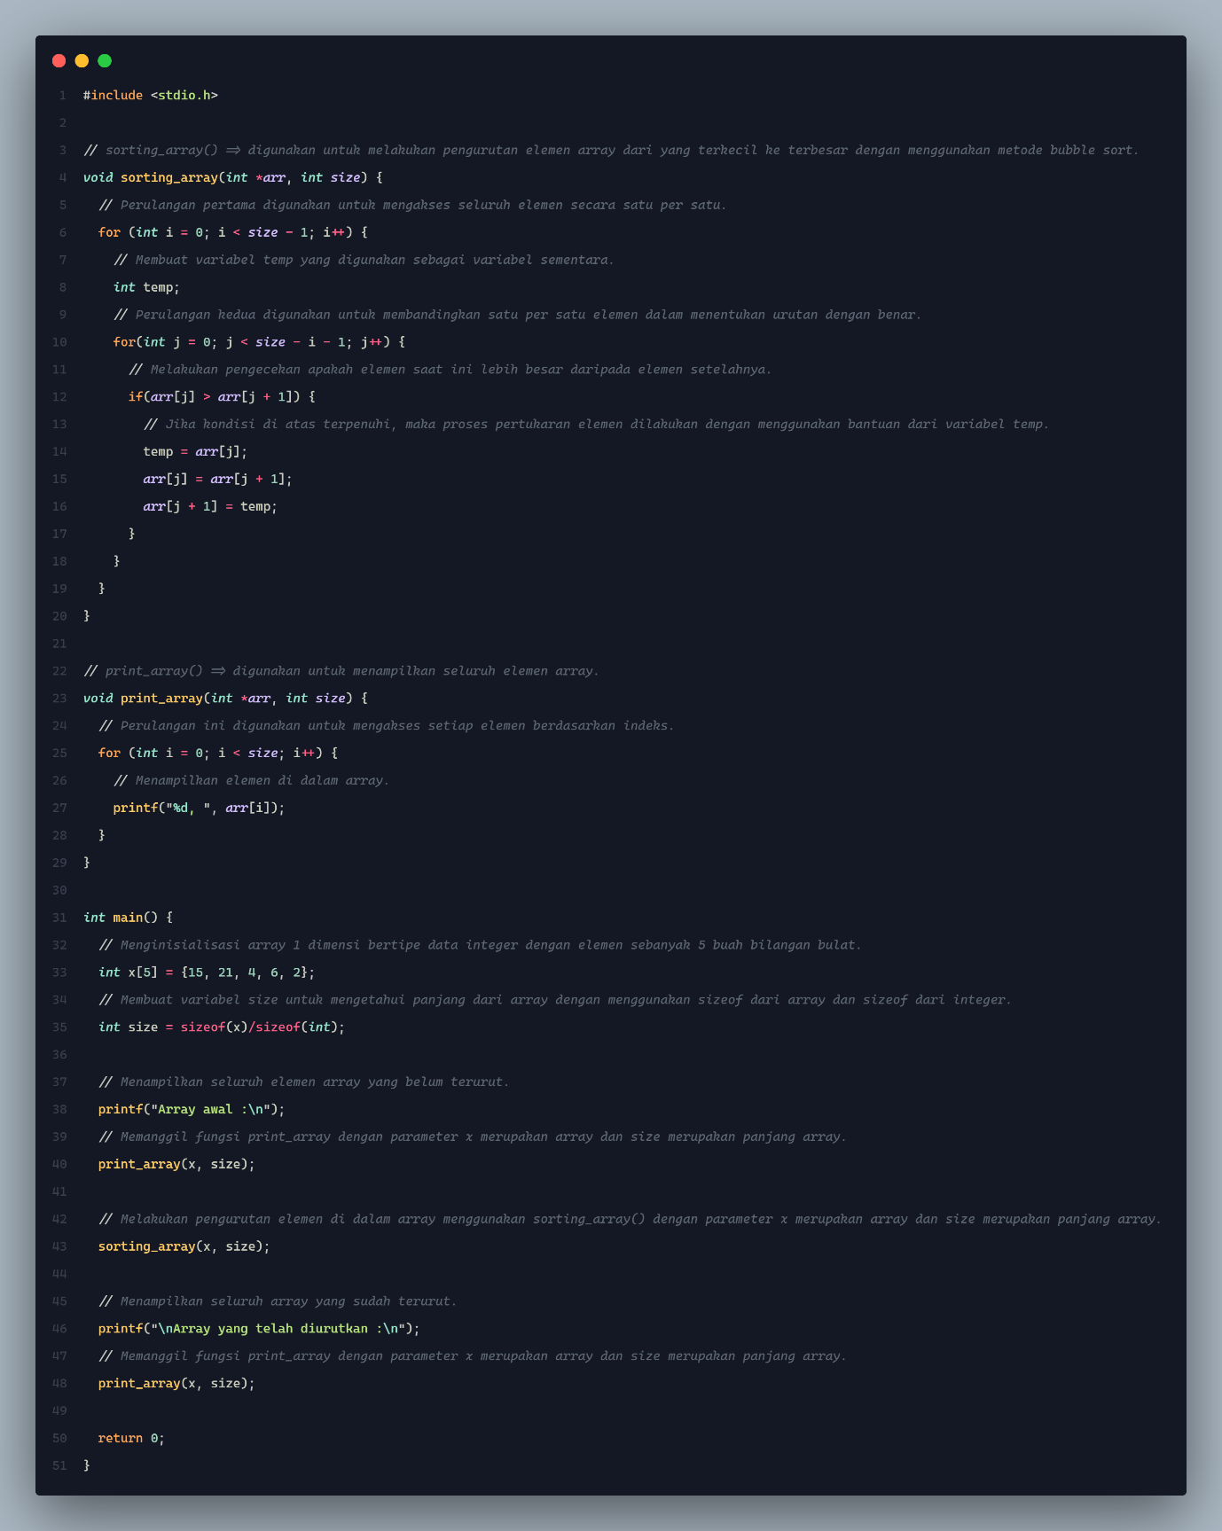Source Code:

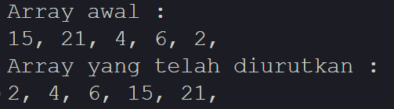Output:

1. 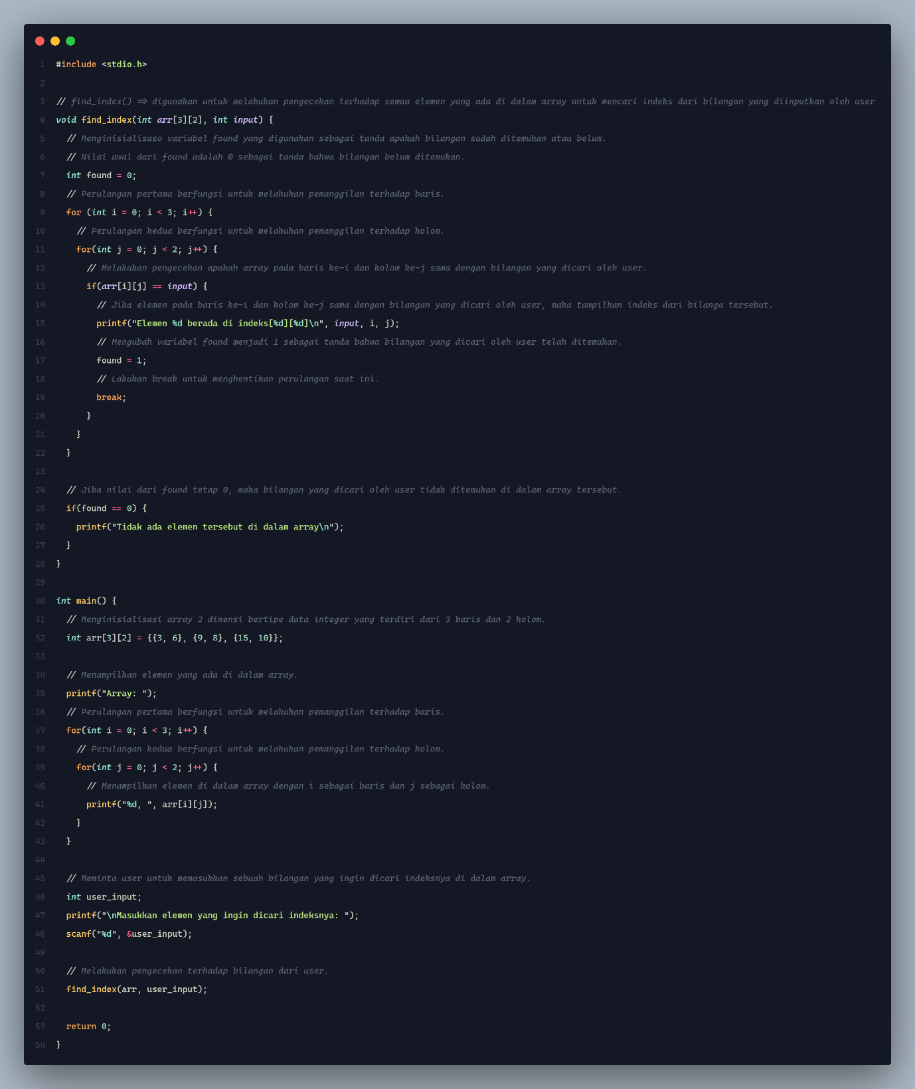Source Code:

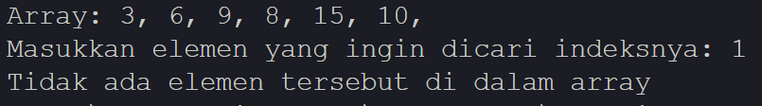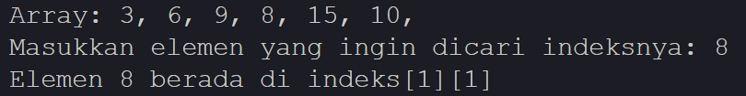Output:

1. 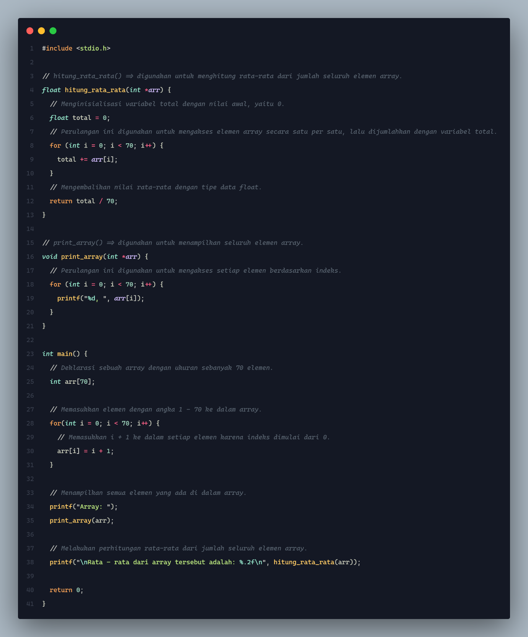Source Code:

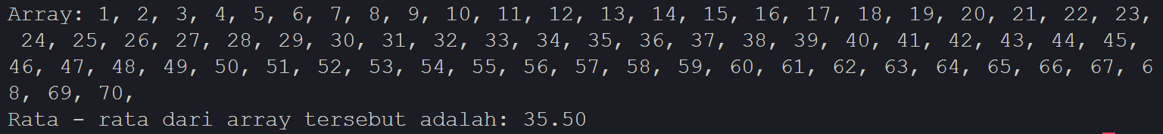Output:

1. 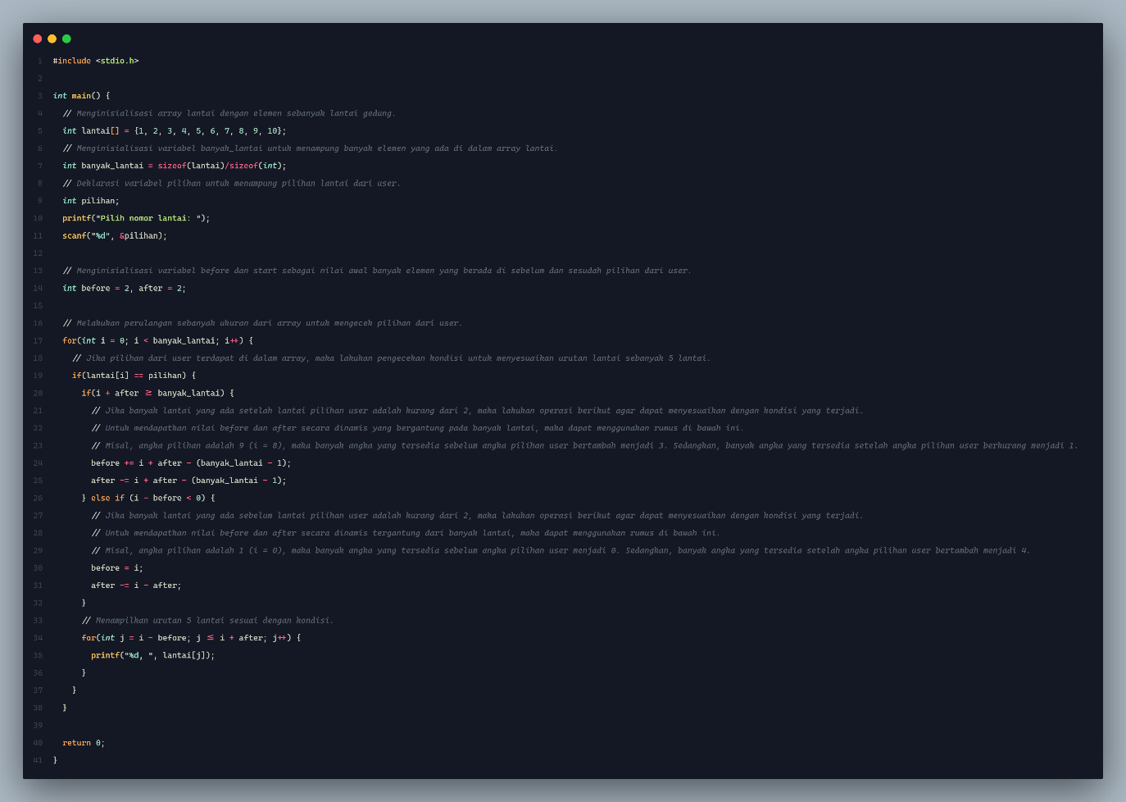Source Code:

Output:

